Mitchell A. Plummer and Carl D. Palmer

IDAHO nATIONAL lABORATORY

**Tracer Analysis Toolbox**

**An Application for Design and Interpretation of Tracer Tests for Estimating Thermal Drawdown in Geothermal Systems**

**User’s Manual**

Abstract

Site operators often inject cold water into geothermal reservoirs to aid in the recovery of subsurface heat and to maintain pressures within the reservoir. A consequence of such injection is the potential for thermal drawdown, where the temperature of the extracted fluid decreases because of the breakthrough of the cold water. The industry needs a method for measuring and extrapolating the migration of cold-fluid fronts through the reservoir that uses the existing facility infrastructure of wells, providing a cost-effective estimate of thermal breakthrough. Detection of potential thermal drawdown before it occurs at the extraction well would be of significant benefit to geothermal operators for optimal reservoir performance and economic return. A potential method for estimating how far a cold front moves between the injection well and the production well is by measuring the concentrations of injected reactive tracers, whose rate of degradation depends on the reservoir temperature between the two wells (e.g., Robinson 1985). With repeated tests, the rate of migration of the thermal front can be determined, and the time to thermal breakthrough calculated.

This document describes operation of the Tracer Analysis Toolbox (TAT), a software program for assisting site operators and engineers in estimating thermal drawdown in conventional and enhanced geothermal systems. The primary purpose of this toolbox is the design and interpretation of tracer tests using thermally reactive solutes.

Contents

Abstract i

1 Introduction 1

1.1 Purpose 1

1.2 Scope 1

1.3 Document Overview 2

1.4 Definitions and Acronyms 2

2 System Architecture 2

2.1 Design Platform 2

2.2 System Architecture 2

3 Data Design 3

3.1 Reactive Tracer Database 3

3.2 Variable Naming Conventions 4

4 Workflows 4

4.1 Introduction 4

4.2 Design Workflow 4

4.2.1 Conservative Tracer Task 5

4.2.2 Temperature Profile 7

4.2.3 Tracer Selection 10

4.2.4 Reactive Tracer 11

4.3 Analysis Workflow 11

4.3.1 Conservative Tracer Task 12

4.3.2 Reactive Tracer Task 13

5 Component Design 13

5.1 Overview of User Interface 13

5.2 Main Screen 13

5.3 Design Workflow 14

5.3.1 Conservative Tracer Task 14

5.3.2 Temperature Profile Task 18

5.3.3 Tracer Selection Task 18

5.3.4 Reactive Tracer Task 22

5.4 Analysis Workflow 22

5.4.1 Conservative Tracer Task 22

5.4.2 Reactive Tracer Task 24

6 References 25

**List of Figures**

Figure 1. Generalized flow chart for the Tracer Analyzer Toolbox. 3

Figure 2. Flow and transformation of input through the Design Workflow. 5

Figure 3. Integral of the product of the density and heat capacity of liquid water at the vapor saturation line as a function temperature. Data from NIST Steam program. 9

Figure 4. Error between the calculated integral and the fitted integral. 9

Figure 5. Flow and transformation of input in the Analysis workflow. 12

Figure 6. Main screen for the Tracer Analysis Toolbox. 14

Figure 7. Conservative tracer task page along the Design workflow when the x-axis is “Time” and Sum Concentrations is “No”. 15

Figure 8. Conservative tracer task page along the Design workflow when the x-axis is “Time” and Sum Concentrations is “Yes”. 17

Figure 9. Conservative tracer task page along the Design workflow when the x-axis is “Distance” . 18

Figure 10. Tracer Selection task window. Numbers in red enumerate items described in the text. 21

Figure 11. Mockup of Conservative Tracer Analysis task window within the Analysis workflow. 23

**List of Tables**

Table 1. List of abbreviations and acronyms. 2

Table 2. List of parameters to be included in the tracer database. 4

Table 3. Scaling parameters for dispersivity. 6

# Introduction

## Purpose

This document describes the Tracer Analysis Toolbox (TAT), a software package for estimating thermal drawdown in geothermal systems. The primary purpose of this toolbox is the design and interpretation of tracer tests using thermally reactive solutes. This document describes the proposed software architecture, required data, component strategies, and the human interface design. We intend this document to be used by the development team to ensure that key elements of the software design meet the requirements specified in the software requirements analysis. In addition, it will serve as a template for a final report of the software design once the program has been completed

## Scope

The injection of cold fluids into engineered geothermal systems (EGSs) and conventional geothermal reservoirs can help extract heat from the subsurface or to maintain pressures within the reservoir (Rose et al., 2001). As these injected fluids move along fractures, they gain heat from the rock matrix and remove it from the reservoir with extraction of the heated fluid to the surface. A consequence of such injection is the migration of a cold-fluid front through the reservoir that could eventually reach the production well and lower the produced fluid’s temperature (thermal breakthrough). Efficient operation of an EGS and conventional geothermal systems involving cold-fluid injection requires accurate and timely information about thermal depletion of the reservoir.

In principle, one can track cold-fluid fronts by measuring temperature in monitoring wells between the injection well and the production well; however, the installation of such a monitoring system would involve large capital costs and is unlikely to occur at most EGS/conventional geothermal facilities. What is needed is a method for measuring and extrapolating the migration of cold-fluid fronts through the reservoir that uses the existing facility infrastructure of wells, providing a more cost-effective estimate of thermal breakthrough.

A potential method for estimating how far a cold front moves between the injection well and the production well is by measuring the concentrations of injected reactive tracers, whose rate of degradation depends on the reservoir temperature between the two wells (e.g., Robinson 1985). With repeated tests, the rate of migration of the thermal front can be determined, and the time to thermal breakthrough calculated.

The goal of this project is to develop a software package that site operators and engineers can use to estimate thermal drawdown in their reservoirs using the thermally reactive tracer method. Our objectives are to develop a software package that can help users 1) identify tracers that are likely to be sensitive to thermal changes in the reservoir, 2) calculate potential responses of tracers within their reservoir, and 3) determine the amount of thermal drawdown based on measured concentrations of thermally reactive tracers. Accurate predictions of the time to thermal breakthrough and subsequent rate of thermal drawdown are necessary for reservoir management, design of fracture stimulation and well drilling programs, and forecasting of economic return. If the time to thermal breakthrough occurs earlier than expected, investors may lose revenues they do not meet expected energy delivery. Alternatively, if thermal breakthrough occurs on a much longer time scale than expected, investors may miss opportunities for increased power generation and revenues. Greater certainty regarding these issues will likely lead to greater investment and increased penetration of geothermal into energy markets.

## Document Overview

After describing the purpose and scope of this document, we give an overview of the system before getting into details of the design platform, system architecture, and design rationale. The data required to use the program is described and a variable naming convention discussed. The key software components to be developed for the program and their relationship to one another are discussed. Finally, potential human interfaces are illustrated.

## Definitions and Acronyms

Table 1. List of abbreviations and acronyms.



# System Architecture

## Design Platform

The TAT was developed on computers running the Windows 10 operating system and tested on a machine running Windows 11. The software is written as an application using the MATLAB (R2022b) App designer environment and has been compiled using the MATLAB Compiler so that it can be operated by any user with the executable and the MATLAB runtime engine.

## System Architecture

A general flow chart of the software package (Figure 1) shows the relationship between the various components. When the program is launched, a splash screen will appear for approximately five seconds. The main program screen is then opened and the user can select to explore information about the program via four tabs (Configure, Help, Notice and Restrictions, About) or choose one of two workflows (Design or Analysis) by clicking the appropriate button. Another key element in the system architecture is the tracer database which contains information about various thermally reactive tracers that have been reported in the literature. Information about specific tracers can be accessed through the Tracer Selection and Reactive Tracer routine in the Design Workflow and in the Reactive Tracer routine in the Analysis Workflow. The database can be modified using a text editor.



Figure 1. Generalized flow chart for the Tracer Analyzer Toolbox.

# Data Design

## Reactive Tracer Database

Information on thermally reactive tracers that could be potentially used will be stored in a database file. The file will be stored as a either a comma delimited file or as Microsoft Excel Worksheet for easy access and modification. The CAS registry number will provide a unique identifier for the tracer compound. Other parameters that will be included in the database and a brief description of those parameters and the data type are listed in Table 2

Table 2. List of parameters to be included in the tracer database.



## Variable Naming Conventions

The program follows lower case camel case convention for naming variables and functions, i.e., making the first letter lower case and the first letter of “words” in the name capitalized. Global variables and functions will start with the workflow name (e.g., “design”) successively followed by the names of objects where the name is located or used. For example, *designConParamPnlReadDataButton* designates an object (*ReadDataButton*) in the Parameter Panel (*ParamPnl*), for the conservative tracer figure (*Con*), in the design workflow. Similarly, *designConParamPnlReadDataButtonPushed* denotes a function that is executed when that button is pushed. For local variables, we will still use lower case camel case but using “words” that make the meaning clear in context of the function.

# Workflows

## Introduction

The user can choose one of two workflows: Design or Analysis. The Design workflow is to aid the user in designing a tracer test and solves the appropriate equations using forward methods. The Analysis work flow helps the user interpret the results of tracers tests and primarily uses optimization methods within MATLAB. In the absence of actual tracer test data, the Design workflows can be used to generate synthetic tracer test results, to explore how the reservoir might behave under hypothetical conditions.

## Design Workflow

The key tasks in the Design Workflow are to calculate the behavior of a conservative tracer, develop potential temperature profiles between the cold-water injection point and the extraction well, choose an appropriate reactive tracer, and simulate the behavior of the reactive tracer in the reservoir. The requirements and outputs along the design workflow are shown in Figure 2 which serves as a basis for developing the coding for this section of the program.



Figure 2. Flow and transformation of input through the Design Workflow.

### Conservative Tracer Task

The equation for the conservative tracer is based on an instantaneous injection of the mass, M, of tracer being injected into the reservoir at a distance of L (e.g., Crank, 1975, Equation 2.6, p. 12). We have included an option for the weighted sum of breakthrough curves from individual flow paths or channels through the rock mass similar to the approach used in the TRINV program (e.g., Arason and Bjornsson, 1994; Francisco and Montalvo, 1996).

|  |  |  |
| --- | --- | --- |
|  |  | (1) |

where

Cc(t) = concentration of conservative tracer at distance Li and time t (kg/m3)

rf = fluid density (kg/m3)

vi = velocity in channel i (m/day)

Mc = mass of tracer instantaneously injected into reservoir (kg)

Q = mass extraction rate of fluid (kg/day)

Li = travel path length between injection point and extraction well (m)

ai = dispersivity (m)

fi = mass fraction of extracted water that flows along channel I (dimensionless)

nch = number of channels

Tapprox = approximate reservoir temperature (days)

Dh = drop in hydraulic head between the injection point and the extraction well (m)

Tapprox is needed only to make an estimate of the fluid density at vapor saturation and a rough approximation is adequate. The algorithm for calculating these densities has an error of < 0.1% over the temperature range of 7 to 362°C (280 – 635K).

The calculation yields Cc(xi,t) or Cc(x,ti) depending on the user’s choice of plotting concentration against time or against distance and the weighted sum of the concentrations in each channel if the user selects the summation option. The fracture apertures, 2bi, are then calculated using Dh in

|  |  |  |
| --- | --- | --- |
|  |  | (2) |

which can then be used to calculate the fracture permeabilities via the cubic law

|  |  |  |
| --- | --- | --- |
|  |  | (3) |

The inclusion of dispersivity as fitting parameters can lead to problems because of the similarity in the shapes of curves for different combinations of parameters even for a single channel. To circumvent this problem, we constrain the values of dispersivity by the scaling low which is given by

|  |  |  |
| --- | --- | --- |
|  |  | (4) |

(Schulze-Makuch, 2005; Neuman, 1990; Neuman, 2006). Suggested values for the scaling parameters (c, m) are provided in Table 3.

Table 3. Scaling parameters for dispersivity.



### Temperature Profile

The second task in the Design Workflow is to calculate the temperature profile. One method of calculating this profile is (Carslaw and Jaeger, 1959, Section 15.3, Case III) which is applicable to each channel in the system

|  |  |  |
| --- | --- | --- |
|  |  | (5) |

where

|  |  |  |  |
| --- | --- | --- | --- |
| cp,f | = | specific heat capacity of the fluid  Calculated at the vapor saturation temperature | (J/(g°C)) |
| cp,r | = | specific heat capacity of the rock | (J/(g°C)) |
| Li | = | Travel path length between injection point and extraction well | (m) |
| nch | = | Number of channels | (dimensionless) |
| T(xr,i,top,i) | = | Temperature in channel i as a function of xr,i at time top | (°C) |
| Tinit | = | temperature in extraction well at time zero (=T(1,0,i) for every i) | (°C) |
| Tinj | = | temperature of injection fluid | (°C) |
| top | = | time over which the cold water has been injected | (days) |
| vi | = | Fluid velocity | (m/s) |
| x | = | distance between injection well and extraction well | (m) |
| xr,i | = | relative distance in channel i between injection well and extraction well (x/Li) | (dimensionless) |
| lr | = | thermal conductivity of the rock | (W/(K m2)) |
| rf | = | Fluid density  Calculated at the vapor saturation temperature | (kg/m3) |
| rr | = | density of the rock | (kg/m3) |

At the extraction well, waters from the various channels are mixed. The temperature of the extracted water is determined by an enthalpy balance:

|  |  |  |
| --- | --- | --- |
|  |  | (6) |

where

|  |  |  |  |
| --- | --- | --- | --- |
| fi | = | Mass fraction of extracted fluid from channel i | (dimensionless) |
| nChn | = | Number of channels | (dimensionless) |
| T(1, top, i) | = | Temperature in channel i at the extraction well at time top | (°C) |
| Tmix | = | Average temperature of extracted fluids after mixing in well | (°C) |
|  |  |  |  |

The mass fraction of extracted fluid from channel i is calculated internally from

|  |  |  |
| --- | --- | --- |
|  |  | (7) |

The integral in Eq. (6) can be determined by numerically integrating the product rf(T)*cp,t(T) over temperature using values from the Steam Tables. We can then obtain the integral as a function of temperature then can be fitted with a polynomial equation. The integral from T(1, top, i) to Tmix can then be determined by

|  |  |  |
| --- | --- | --- |
|  |  | (8) |

where Tref is an arbitrary starting temperature which is chosen here to be 280K. Combining Eq. (8) with Eq. (6)

|  |  |  |
| --- | --- | --- |
|  |  | (9) |

Rearranging Eq. (9)

|  |  |  |
| --- | --- | --- |
|  |  | (10) |
|  |  |  |
|  |  | (11) | |

But,

|  |  |  |
| --- | --- | --- |
|  |  | (12) |

therefore,

|  |  |  |
| --- | --- | --- |
|  |  | (13) |

The term on the LHS of (13) is the integral of the product of the density and heat capacity of the fluid mixture. Thus, we can use the fitted equation for the integral of the product of the density and heat capacity of the water to calculate the RHS of Eq. (13). This results in a nonlinear equation that can be solved to yield the temperature of the mixture. Tests using Newton’s method suggest that 3-4 iterations are all that are needed to solve if a guess within the valid temperature range is used. The weighted average of the temperatures is a reasonable initial guess of the temperature and would likely be within 10°C of the actual temperature. The equations used are valid for 280 ≤ T ≤ 645 K.

The integral of the product of the heat capacity and the density of water is fitted with a 6th order polynomial over the range of 280-640K (Figure 3) at 5K intervals. The errors between the calculated integral and the fitted integral values as a function of temperature show error < 0.5% for 325 ≤ T ≤ 635K with error increasing to -6.1% at 645K and 12.8% at 285K (Figure 4).



Figure 3. Integral of the product of the density and heat capacity of liquid water at the vapor saturation line as a function temperature. Data from NIST Steam program.



Figure 4. Error between the calculated integral and the fitted integral.

We can also supply an option for the Gringarten et al. (1975) solution which is given in the Laplace transform space as

|  |  |  |
| --- | --- | --- |
|  |  | (14) |

with dimensionless time (tD) defined by

|  |  |  |
| --- | --- | --- |
|  |  | (15) |

Gringarten et al. (1975) did not provide an explicit inversion for the solution in the Laplace space and instead used numerical inversion. A solution for an analogous problem for solute transport in fractured, porous media (Sudicky and Frind, 1982) does provide an inversion but it is complicated and is an infinite series that is slow to converge. Thus, numerical inversion provides a more efficient means of calculating the solution.

### Tracer Selection

The concentration of a reactive tracer from a single channel is

|  |  |  |
| --- | --- | --- |
|  |  | (16) |

where Mr and Mc are the mass of reactive and conservative tracers. The l is the temperature-dependent pseudo-first-order rate coefficient which for constant reservoir temperature and is given by the Arrhenius equation:

|  |  |  |
| --- | --- | --- |
|  |  | (17) |

where Ea is the activation energy, A is the pre-exponential factor, R is the gas constant, and T is the reservoir temperature (kelvin). Dividing Eq. (16) by Eq. (1) one obtains

|  |  |  |
| --- | --- | --- |
|  |  | (18) |

However, we are interested in the case where the reservoir temperature is no longer constant but varies continuously between the tracer injection point and the fluid extraction well. Under these conditions, the rate coefficient can be considered an effective value (leff) which is dependent on the average (or effective) reservoir temperature and Eq. (17) is written as

|  |  |  |
| --- | --- | --- |
|  |  | (19) |

where the function T(xr) is given by Eq. (5) and xr = x/L where L is the distance between the tracer injection point and fluid extraction well. Alternatively, others consider T in Eq. (17) to be an effective temperature, Teff, given by

|  |  |  |
| --- | --- | --- |
|  |  | (20) |

The choice of tracer depends on the sensitivity of change in tracer concentration to the change in the effective temperature, i.e., dCrel/dTeff (Plummer et al., 2012). This sensitivity is

|  |  |  |
| --- | --- | --- |
|  |  | (21) |

### Reactive Tracer

Combining Eqs. (18) and Eq. (19) and allowing for multiple channels and mixing, the concentration of a reactive tracer at the extraction well is

|  |  |  |
| --- | --- | --- |
|  |  | (22) |

where

|  |  |  |  |
| --- | --- | --- | --- |
| A | = | Pre-exponential factor for the degradation of reactive tracer | (s-1) |
| Cc,i(t) | = | Concentration of conservative tracer from extraction well | (mg/Kg) |
| Cr,i(t) | = | Concentration of reactive tracer from extraction well | (mg/Kg) |
| Ea | = | Activation energy for degradation of reactive tracer | (kJ mol-1) |
| fi | = | Mass fraction of fluid from channel i | (dimensionless) |
| Mc | = | Injected mass of conservative tracer | (mg) |
| Mr | = | Injected mass of reactive tracer | (mg) |
| nch | = | Number of channels | (dimensionless) |
| R | = | Universal gas constant | (J mol-1 K-1) |
| T(xr,i,top) | = | Temperature in channel i as a function of xr,i at time top | (°C) |
| x | = | distance between injection well and extraction well | (m) |
| xr,i | = | relative distance in channel i between injection well and extraction well (x/Li) | (dimensionless) |

Ti(x) is the temperature profile in channel i given Eq. (5).

## Analysis Workflow

The Analysis workflow is used to interpret conservative and reactive tracer data that has been collected. The workflow uses the concentration versus time data from the tracer test and by use of optimization functions within MATLAB, calculates reservoir parameters, such as the length and velocity of each flow path and the mass fraction contribution from each channel.



Figure 5. Flow and transformation of input in the Analysis workflow.

### Conservative Tracer Task

The conservative tracer task in the Analysis workflow (Figure 5), requires input consisting of the number of channels (nch), the mass of conservative tracer (Mc), the pumping rate (Q), an estimate of the effective reservoir temperature (Test), and the concentration of the conservative tracer in the extraction fluid (Cc,tot(t)). The concentration in the extraction fluid is the weighted sum of the concentrations from each of the channels.

|  |  |  |
| --- | --- | --- |
|  |  | (23) |

The optimization codes within MATLAB are then used to calculate the velocity (vi), length (Li), dispersivity (ai) and mass fraction contributions (fi) for each channel I using Eq. (1). Once these parameters are calculated, the concentration versus time curves for each channel can be calculated in a forward manner. With the additional input of the head drop from the injection point to the extraction well (Dh), the fracture aperture be calculated from

|  |  |  |
| --- | --- | --- |
|  |  | (24) |

The cubic law can then be invoked to calculate the fracture permeability in each of the channels

|  |  |  |
| --- | --- | --- |
|  |  | (25) |

### Reactive Tracer Task

For the reactive tracer optimization task, the activation energy (Ea) and the pre-exponential factor (A) of the reactive tracer must be input. In addition, the measured concentration of the reactive tracer in the extraction water (Cr,tot(t)) must be provided. The concentration of the reactive tracer in the extraction water is the weighted sum of the concentrations in the individual channels

|  |  |  |
| --- | --- | --- |
|  |  | (26) |

(compare to Eq. (23) for the conservative tracer) where the fi have been obtained from fitting the conservative tracer data. Optimization with the MATLAB functions of Eq. (22) leads to values of Teff,i for each of the channels, i. For each of the Teff,i, and using the Li, vi, fi, and bi calculated from the conservative tracer analysis, the thermal conductivity (lR) and heat capacity (cp,R) of the rock mass can be estimated by optimization using Eqs. (20) and (5). Once the rock thermal properties are known, the temperature profiles in each of the channels can be directly calculated using Eq. (5).

# Component Design

## Overview of User Interface

The Tracer Analysis Toolbox was developed using the MATLAB App Designer. Key components of this application are the main screen, which directs the user to the Design workflow or the Analysis workflow. The Design workflow comprises four task windows that are used to explore conservative tracer responses, construct temperature profiles, select potential tracers, simulate reactive tracer behaviors. In the Analysis workflow, there are two task pages: Conservative Tracer Analysis and Reactive Tracer Analysis. The operation of these windows is discussed in more detail in the following sections.

## Main Screen

The main screen (Figure 6) comprises a Design button that takes the user to the design workflow and an Analysis button that opens the data analysis workflow. In addition, there are four tabs for accessing information about TAT. The About tab opens a window (**Error! Reference source not found.**) that contains basic information about TAT, including the version, project team, copyright, and contract under which we initiated the project. The Notice tab opens a pdf file (**Error! Reference source not found.**) that contains information about the distribution, licensing, and liabilities associated with the program. Departments at INL prior to release will update and review this page. The Help tab will open a pdf file that is the TAT User’s Manual so that the user can search for program information. The Configure button will open a menu that will allow the user to reset files, such as the reactive tracer database, to their default values.

Figure 6. Main screen for the Tracer Analysis Toolbox.

## Design Workflow

### Conservative Tracer Task

Upon clicking the Analysis button in the main menu, the conservative tracer task page opens. This task page lets the user explore the potential breakthrough curves for conservative tracers injected into the system. These calculations would likely be based on preliminary information about the geothermal system through pressure tests, geophysical surveys, and known geology. The results have these simulations can aid users in determining the time scales for tracer breakthrough and the expected tracer concentrations, information critical for designing and executing conservative tracer tests.

Along the top of the Conservative Tracer task page (Figure 7) just below the heading, are four buttons that can be clicked to open other task pages in the workflow. Clicking on a button of a task page that is already open causes the task page to be brought to the front and centered on the screen. Below these buttons are three panels labelled Parameters, Plotting Options, and Plot.

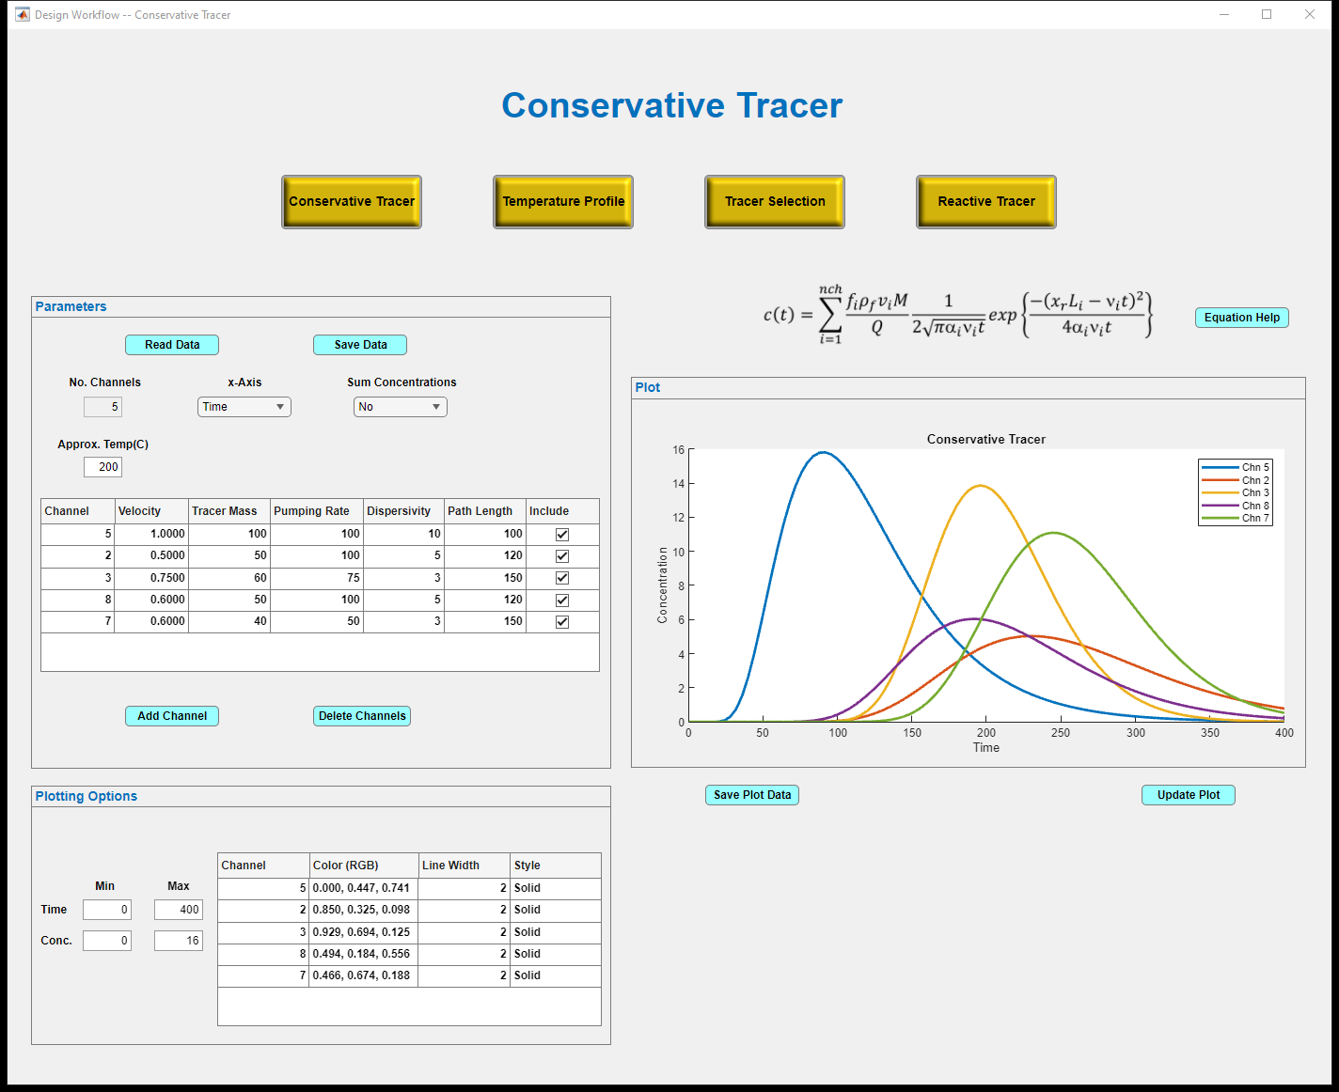

Figure 7. Conservative tracer task page along the Design workflow when the x-axis is “Time” and Sum Concentrations is “No”.

Figure 9 shows a case where 5 channels are considered. Within the Parameters panel, the x-axis dropdown menu is used to select whether the concentrations are to be plotted against time or distance. The Sum Concentrations dropdown menu provides the user with the choice of calculating a weighted average of the tracer concentrations in the channels. The user provides an approximate reservoir temperature in the Appox. Temp(°C) numerical edit field so the fluid density can be calculated. The program uses an approximating function for calculating this density at the vapor saturation pressure based on density values from Allan and Eric (2013). This function has |errors| < 0.08% over the temperature range of 280 to 635K (7 - 362°C).

For the choices of “Time” for the x-axis and “No” for Sum Concentrations, the parameters listed in the parameter table include Channel, Velocity, Tracer Mass, Pumping Rate, Dispersivity, and Path Length. In addition, there is an Include column of check boxes. If the box is checked, the plot for that channel appears in the graph. If unchecked, the plot does not appear in the graph. The channel designation is a unique integer value that can appear in any order. A new channel can be added to the table by simply clicking the Add Channel button. A new line will appear in the table with a channel number equal to the maximum channel number plus one and the No. Channels numerical edit field is incremented by one. A maximum of 10 channels can be used. The table can be edited so any of the values changed. Above the plot is the equation being applied. The parameter definitions, equation assumptions, and references can be found by clicking on the Equation Help button just to the right of the equation. This button opens a pdf file containing information about the equation and its application.

To delete channels, click on the Delete Channels button. A dialog box appears in which the channel numbers that you want deleted are listed in a space-separated format. After clicking “OK”, the listed channels are deleted and the No. Channels numerical edit field is updated. After the table and other fields in the Parameters panel have been completed, the user can save the information in a text file by clicking of the Save Data button near the top of the panel. If a file has already been created, it can be read by clicking on the Read Data Button. To see the plot, the user must click the Update Plot button on the right just below the graph. The user also has the option to save the plot data in a text file by clicking on the Save Plot Data button. This plot file can then be imported into the user’s favorite plotting software package. In addition, the plot can also be exported as a raster or vector graphics file be using the buttons that appear when the cursor hovers over the area just above the upper right corner of the graph.

The appearance of the plot can be altered by changing entries in the Plotting Options panel. Ranges on the x-axes and y-axis (concentration) can be changed using the numerical edit fields on the left of the panel. The use of “inf” in the field allows MATLAB to choose the default value. While this feature is useful for the maximum value of concentration, we do not recommend its use in any of the other fields. The color, line width, and line style of a channel can be changed by clicking on the appropriate table entry. Clicking on the color entry will open the MATLAB color menu that can be used to change the line colors. Clicking on a style menu will open a dropdown menu from which the user may select dash-dot, dashed, dotted, solid, or none line styles.

The appearance of the Conservative Tracer task page changes depending on the x-axis and the Sum Concentrations choices. For example, when the x-Axis is set to “Time” and the Sum Concentrations is “Yes”, the Tracer Mass and Pumping Rate columns no longer appear in the table but they are entered in two numerical edit field boxes above the table because these values should be common to all channels if the concentrations are to averaged (Figure 8). The table now contains columns for the Channels, Velocity, Dispersivity, Path Length, Fraction, and Include. The fraction denotes the mass fraction of fluid from each of the channels. The sum of the fractions over all the channels should be equal to unity. Also, the sum is only for those channels that are included in the plot. One can view the sum of all the curves but plot only a subset of the curves by including all the curves in the Parameter panel and changing the line style to “None” in the Plotting Options panel for the channels not to be plotted.

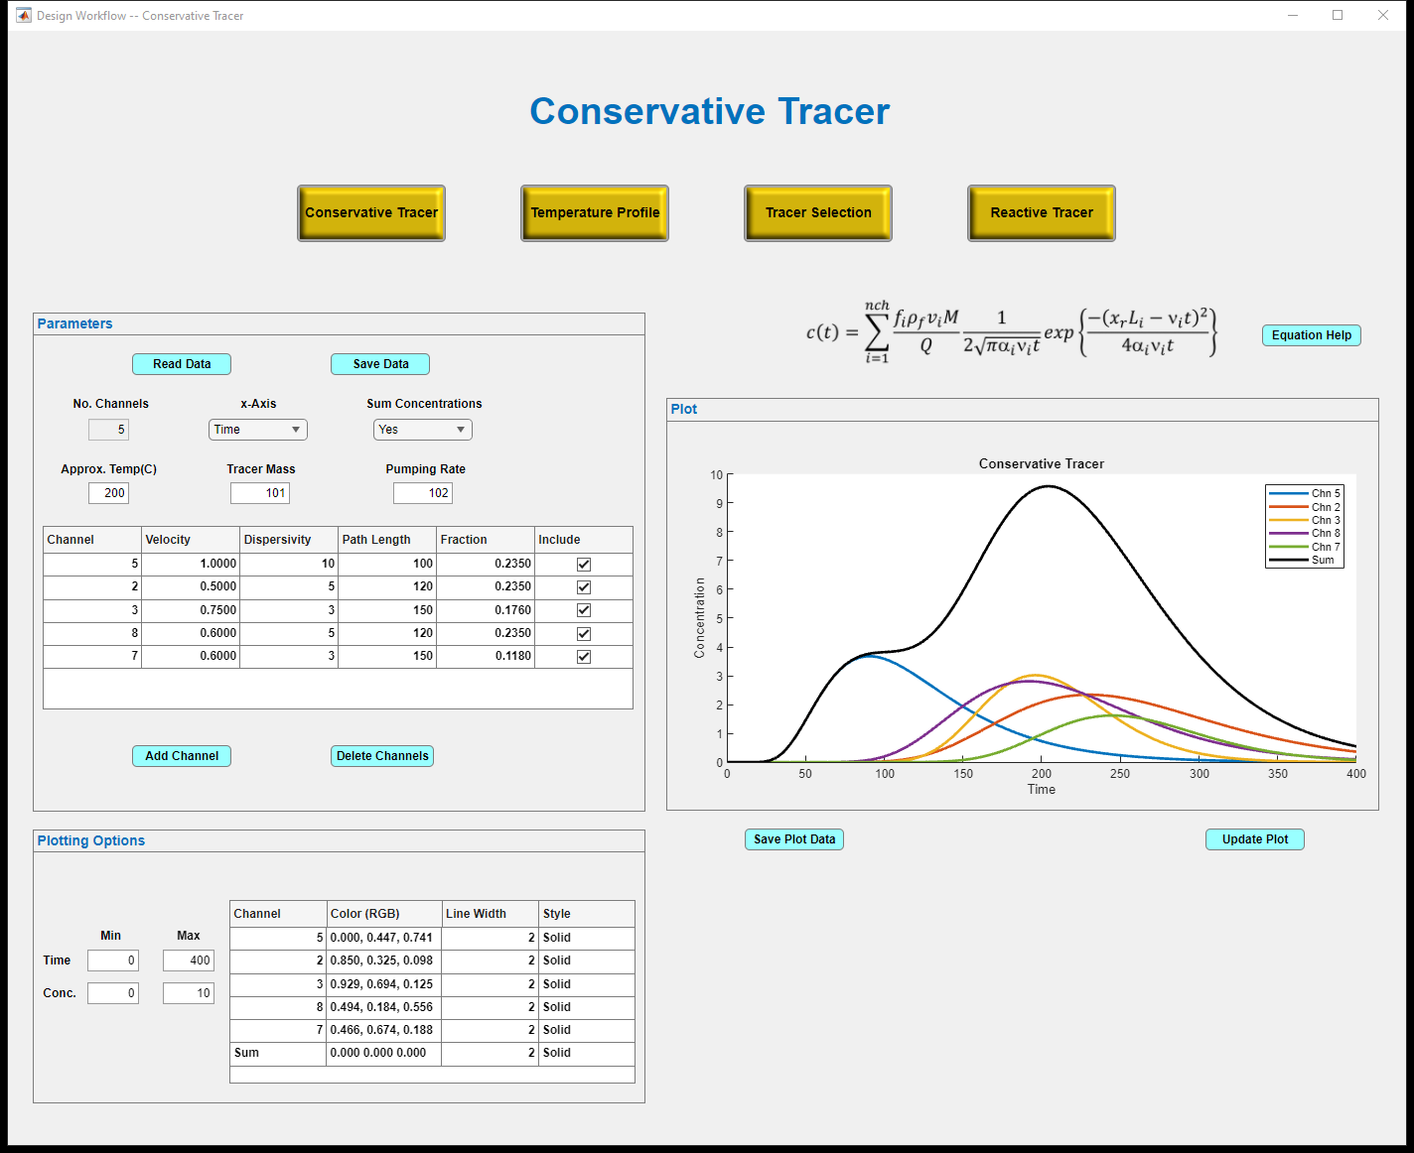

Figure 8. Conservative tracer task page along the Design workflow when the x-axis is “Time” and Sum Concentrations is “Yes”.

When “Distance” is chosen in the x-Axis dropdown box, the sum concentrations dropdown box disappears (Figure 9) because TAT does not permit summing concentrations over distance. In addition, the column of path lengths is the Parameter table is now replaced by a column of times. A new numerical edit field appears, that provides a common path length for all the channels in the table. The “Time” label in the Plotting Options panel is replaced by “Distance”. The x-axis in the Plot panel in a relative value (xr = x/L, where L is the Path Length).

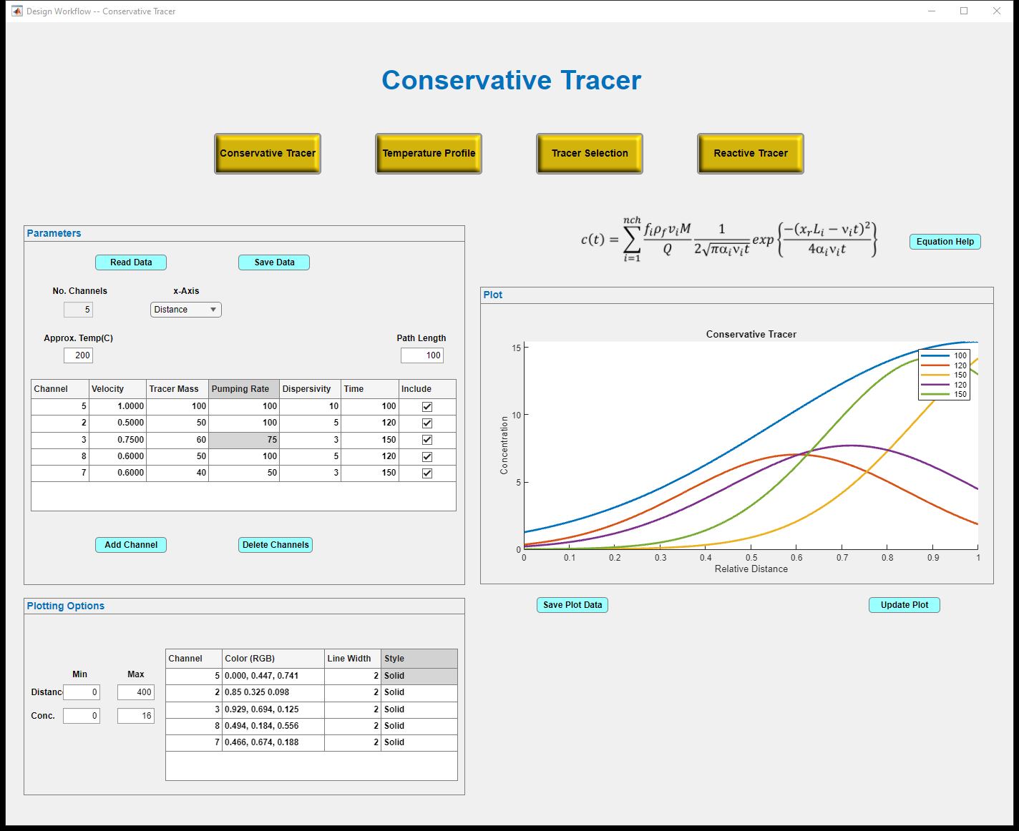

Figure 9. Conservative tracer task page along the Design workflow when the x-axis is “Distance” .

### Temperature Profile Task

The layout of the Temperature Profile task window will be very similar to the Conservative Tracer task window. However, the parameter table will contain the thermal conductivity, heat capacity, and density of the rock and the operating time for the cold-water injection. In addition, the table will include the velocity, fracture aperture, path length, and mass fraction of fluid for each of the channels. The user will choose whether the plot displays the temperature profile for each of the channels or the temperature at the extraction well over time for each channel and the weighted sum of the temperatures.

### Tracer Selection Task

The Tracer Selection window can be used to help determine which tracers are likely to provide the greatest sensitivity to temperature changes in the reservoir given the initial reservoir temperature, flow path lengths, and fracture apertures. The dialog panel contains input parameters describing the reservoir and relevant monitoring criteria and results summaries in four different plots. Figure X shows that panel annotated with numbers for selected features that are described below.

The reservoir parameters are

1. The initial average flowpath temperature, generally referred to as the reservoir temperature.
2. The flowpath residence time, in days, generally estimated from a conservative tracer test.
3. The maximum relative concentration recovered using a conservative tracer. The default value is 1.
4. Maximum likely thermal drawdown likely to occur between an initial condition and a subsequent reactive tracer test.

Each of these values can be taken from the ____ if the user selects the associated checkbox.

The monitoring criteria are:

1. The minimum **change** in relative concentration that one can reliably measure between two tracer tests, which depends on the temperature change experienced by the reservoir, and the sensitivity of the analysis method to a particular tracer.
2. The minimum relative concentration that can be measured, which depends on the injection concentration, dilution during transport and the detection limits of the analysis method.

Each of these values can be taken from the ____ if the user selects the associated checkbox.

As the latter two criteria are dependent on the selected tracer, the tracer selection process should be considered an iterative approach. Results from each calculation provide information about the tracers that may be suitable. Information about the cost of those tracers and the sensitivity and limits of appropriate analytical methods are then used to further refine monitoring criteria and the process is repeated. The initial monitoring criteria assume that a 1% relative concentration can be reliably measured and that a 5% change in concentration can be reliably measured.

Output plots depict tracer response under specified conditions and identify which tracers meet – for a temperature change between -0.1°C and the specified likely maximum temperature (4) - the specified minimum relative concentration (5) and minimum change in relative concentration (6). The output includes one primary figure:

1. A semi-log plot of the temperature change (°C) required to produce the user-specified fractional change in relative concentration at a range of initial flowpath temperatures. Curves are shown for each tracer in the database, with those meeting the selected criteria shown in bold, with colors matching those in the other plots that focus on those tracers. Tracers that meet the criteria intersect the effective reservoir temperature line (Teff) between a temperature change between 0.1°C and the maximum likely temperature change (4). The minimum temperature change used to identify suitable tracers represents a lower limit for meaningful reservoir temperature decline.

Three other plots and one table show data for just those tracers (legend in lowermost right corner) that meet the selected criteria. These include the following:

1. A bar plot showing the initial and final concentration of each tracer that meets the selected criteria. As the reservoir cools, reaction rates decline accordingly so that later tests typically result in higher tracer recovery.
2. A line plot showing the relative concentration of each tracer that meets the selected criteria, as a function of the temperature change experienced in the reservoir.
3. A line plot showing the fractional change (%) in the relative concentration of each tracer that meets the selected criteria, as a function of the temperature change experienced in the reservoir.
4. A table listing the tracers that meet the specified criteria, showing database values for those compounds and results for the conditions under which the monitoring criteria are met.

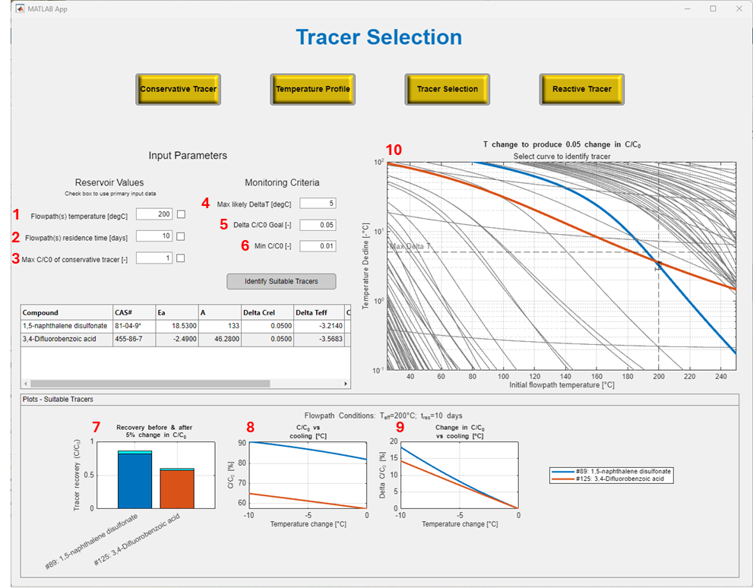

Figure 10. Tracer Selection task window. Numbers in red enumerate items described in the text.

To estimate which tracers may perform the best, the initial temperature of the reservoir must be known. The time scale that is used is the average residence time in the reservoir. In addition, the maximum C/C0 of the conservative tracer must be known or estimated from the Conservative Tracer task window. When trying to detect a change in temperature between two different tracer tests, we need to specify a maximum temperature change and a change in Cr/Cr,0. A minimum Cr/Cr,0 must also be specified because if the concentration of the reactive tracer falls below detection levels, no information can be obtained.

After clicking the Identify Suitable Tracers button is pushed, the three graphs are generated. The curve in the upper right shows the relative concentration of the reactive tracer as a function of the change in temperature. As expected, the greater the decrease in temperature, the greater the concentration of the reactive tracer. The plot shows that the DB#73 (blue line), most of the tracer is hydrolyzed at the reservoir temperature, but as the reservoir cools, detectable amounts of the tracer appear in the extraction fluid. In contrast, tracer DB#89 (orange line) is more recalcitrant and a significant amount of the tracer (> 80%) can be found in the extraction water even if there is no change in the reservoir temperature. The plot in the lower right is the relative change in Cr/Cr,0 versus the change in temperature. This plot shows the sensitivity of the tracer concentration to temperature changes and is based on the derivative of the reactive tracer concentration versus time equation and is given by Eq. (21). For the example shown in Figure 10, Tracer DB#73 appears much more sensitive that other tracers. However, the tracer will only be effective if the detection limits are such that the concentration can be measured at low relative concentrations. The percent tracer recovery is shown in the lower left of Figure 10 shows little recovery for the DB#73 tracer compared to the other tracers that meet our general criteria.

### Reactive Tracer Task

The layout of the Reactive Tracer task window will be very similar to the Conservative Tracer and the Temperature Profile task windows. The parameter table in the Reactive Tracer task will contain many of the same parameters as the Temperature Profile task window, because the calculation requires the integration of the temperature profile. The user will choose if the plot displays the reactive tracer concentrations for each of the channels or the reactive tracer concentrations at the extraction well over time for each channel and weighted sum of the concentrations.

## Analysis Workflow

### Conservative Tracer Task

The Conservative Tracer task window in the Analysis Workflow shares many of the same features seen in the Design workflow. Just below the window title are two buttons that allow the user to move between the conservative tracer task window and the reactive tracer task window within the workflow (Figure 11). There are four panels in the Conservative Tracer Analysis task window: Parameters, Results, Plots, and Plotting Options. The user first reads measured tracer concentration data by clicking the “Read Data” button. The user can then manually fill in the parameter information in the numeric edit fields and table. Alternatively, the parameter information can be read from a text file. Once the parameter information is entered and modified, it can be saved by clicking on the “Save Param” button. The column of check boxes in the table is used to identify which channels are to be included in the optimization. To the right of the parameter table is a tree checkbox. The user can select which parameters in the table are to be optimized by checking the appropriate. Thus, the parameters in the table represent actual values if its checkbox is not checked and initial guesses if the checkbox is checked.

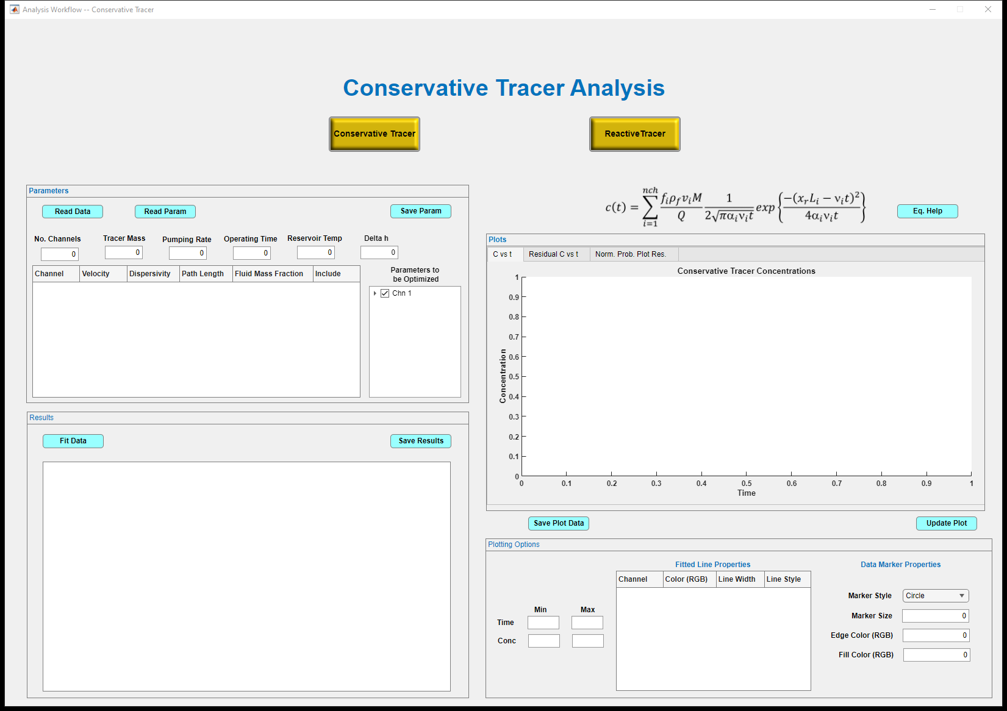

Figure 11. Mockup of Conservative Tracer Analysis task window within the Analysis workflow.

Once the user has entered the parameters, the regression is performed by clicking the “Fit Data” button in the Results panel. This button generates a report summarizing the calculations. The function used to perform the regression could be the fminsearch, lsqcurvefit, or fminunc. The latter two functions are in the MATLAB Optimization toolbox, while fminsearch is in the main MATLAB program. The first section of the generated report will include general regression statistics, including the number of samples, the coefficient of determination (R2), the adjusted R2, and the standard error of the fit. The second section will be the analysis of variance of the regression showing the number of degrees of freedom and the sum of squares for the regression, the residual, and the total, the mean sum of squares for the regression and the residual, The F-statistic, and the probability of the F-statistic. The third section of the results will a list of each fitted parameter with its optimized value, standard error, t-statistic, p-value, and upper and lower 95% confidence limits. The last part of the report will have the covariance matrix, the correlation matrix, the normalized eigen-vectors of the covariance matrix, the eigenvalues and the Kolomogorov-Smirnov test for the normality of the residuals.

In addition, the report will generate estimates of the aperture and permeability of each of the channels using the pressure change between the injection point and the extraction well. These calculations will be done as a forward model using Eqs. (24) and (25). Uncertainties in the values will be calculated using propagation of error in the lengths and velocities for each channel.

There will be three plots in the Plots panel: tracer concentration versus time, the residual concentration versus time, and the normal probability plot of the concentration residuals versus the Z-score. The tracer concentration plot will contain the measured concentration data (shown with markers), plots of the concentrations from each of the channels (shown with lines), and a plot of the weighted sum over all the channels of the tracer concentrations (shown with a line). Data from these plots can be saved by clicking on the “Save Plot Data” button on the left just below the graph. The user can also export the graphs as either raster or vector graphics objects by selecting the appropriate button that appears when the cursor hovers above the upper right corners of the graphs.

Scaling of the axes can be altered by changing the values in the edit fields on the left of the Plotting Options panel below the graph. The look of the lines in the plot can changed be by editing the line color, line width, and line style in the table in the panel. In addition, marker style, size, edge color and fill color for the measured data can be changed using the dropdown boxes and edit fields on the right of the Plotting Options panel.

### Reactive Tracer Task

The Reactive Tracer task page will be very similar to that used for the conservative tracer. Additional parameters that must be added are the pre-exponential factor (A) and activation energy (Ea) for the reactive tracer being used.

# References

Allan, H., Eric, L., 2013. NIST/ASME Steam Properties, Version 3.0. NIST Standard Reference Database 10.

Arason, P., Bjornsson, G., 1994. ICEBOX, 2nd edition. Orkustofnum, Reykjavik, p. 38.

Carslaw, H.S., Jaeger, J.C., 1959. Conduction of Heat in Solids. Oxford University Press, Oxford.

Crank, J., 1975. The mathematics of diffusion. Clarendon Press, Oxford [England].

Francisco, E., Montalvo, L., 1996. Tracer modelling and heat mining calculations for the Ahuachapán geothermal field, El Salvador C.A. Reykjavík : United Nations University : Orkustofnun, 1996.

Gringarten, A.C., Witherspoon, P.A., Ohnishi, Y., 1975. Theory of heat extraction from fractured hot dry rock. Journal of Geophysical Research (1896-1977) 80(8), 1120-1124.

Plummer, M., Palmer, C.D., Hull, L.C., Mattson, E.D., 2012. Sensitivity of a reactive-tracer bnased estimate of thermal breakthrough in an EGS to Properties of the Reservoir and tracer, Proceedings, Thirty-Seventh Workshop on Geothermal Engineering. Stanford University, Stanford, California, January 30 - February 1, 2012, SGP-TR-194.

Rose, P.E., Benoit, W.R., Kilbourn, P.M., 2001. The application of the polyaromatic sulfonates as tracers in geothermal reservoirs. Geothermics 30(6), 617-640.

Sudicky, E.A., Frind, E.O., 1982. Contaminant transport in fractured porous media: Analytical solutions for a system of parallel fractures. Water Resources Research 18(6), 1634-1642.

Toride, N., Leij, F.J., Genuchten, M.T.v., 1993. A comprehensive set of analytical solutions for nonequilibrium solute transport with first‐order decay and zero‐order production. Water Resources Research 29, 2167-2182.